**Name: ……………………………………………. ADM NO: …………………………………..**

**Student’s signature: ……………………………. Date: ..…………….…………………………**

**FANAKA GIRLS HIGH SCHOOL**

**DECEMBER HOLYDAY ASSIGNMENT**

**CHEMISTRY**

**FORM 3**

**INSTRUCTIONS TO CANDIDATES**

* Write your name and index number in the spaces provided above.
* Answer ALL the questions in the spaces provided in the question paper.

1. A wooden splint was slipped through a region of a particular flame of the Bunsen burner in the laboratory. The split was burnt as shown in the diagram

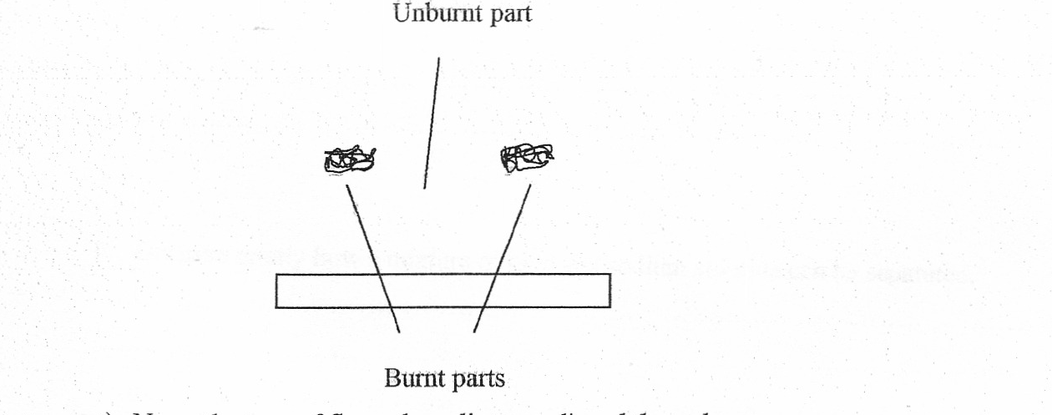

a) Name the type of flame the splint was slipped through. (1mk)

b) Explain why the splint was burnt the way it is shown in the diagram. (2mks)

c) After use, the non-luminous flame should be put off or adjusted to luminous flame. Explain. (2mks)

d) Putting off flames is one of the laboratory safety rules. State THREE other rules. (3mks)

1. Use the grid above to answer the questions that follow. Letters do not represent actual symbol of elements

|  |  |  |  |  |  |  |  |  |
| --- | --- | --- | --- | --- | --- | --- | --- | --- |
|  |  | |  | | | | |  |
| F | I |  |  |  | M |  | O |  |
| G | J |  | K | L |  | N | P |  |
| H |  |  |  |  |  |  |  | Q |

a) What family name is given to elements I and J **(1 mk)**

b) State and explain the difference in reactivity between.

i) G and J **(2 marks)**

ii) N and P **(2 marks)**

c) How does atomic radius of K compare to that of L? Explain. **(2 marks)**

d) Explain the trend in melting points down the group of elements to which I and J belong**. (2 marks)**

e) Write down an equation for the reaction between K and P.  **(1 mark)**

f) Give one use of element Q. **(1 mark)**

i) Write down the electronic arrangement of a stable ion of H. **(1 mark)**

3. The scheme below shows the industrial manufacture of sulphuric (VI) acid. Study it and answer the questions that follow.

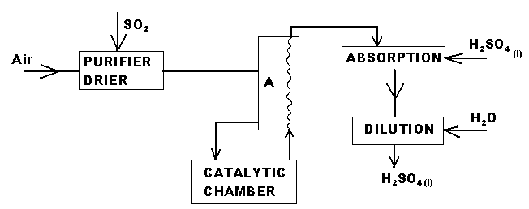

1. State two functions of the chamber A. **(1mark)**
2. Explain why concentrated Sulphuric (VI) acid is used in the absorption chamber and not water. **(1mark)**
3. Write the equation for the reaction that takes place at the absorption chamber **(1mark)**

iv) Name two catalysts that can be used in the catalytic chamber. **(1mark)**

(b) Sulphuric (VI) acid is used in making fertilizers. What volume of ammonia gas will be required to make 25kg of ammonium sulphate? N = 14, H = 1.0, S = 32, O = 16.0 Molar gas volume at r.t.p=24.0dm3) **(3marks)**

4. Study the following table and then use it to answer the questions that follow.

|  |  |
| --- | --- |
| **Hydrocarbon** | **Boiling point (k)** |
| CH4  C2H6  C3H8  C4H10  C5H12  C6H14 | 112  184  231  273  309  342 |

a) These organic compounds belong to the same homologous series.

i) What is meant by the term homologous series? **(1mark)**

1. To which homologous series do the above hydrocarbons belong? **(1mark)**
2. Select one hydrocarbon that would be a liquid at room temperature. **(2marks)**

iv) Compare the boiling point of CH4 and C6H14 ? Explain your answer **(2marks)**

1. Give one chemical test to distinguish between C2H6 and C2H4 **(2marks)**
2. Name the reagents used in

Step I ……………………………………………………………………..… **(1 Mark)**

Step II ……………………………………………………………..…….. **(1Mark)**

ii) Write an equation for the complete combustion of CH≡CH **(1 Mark)**

(i) Describe how nitrogen is obtained from air **(4 marks)**

4) State Charles law (1mk)

b) At a temperature of 30°C, a gas occupies a volume of 300 litres and a pressure of 540mmHg. What would be the pressure if the gas at a temperature of 40°C occupies a volume of 600 litres. **(3marks)**

5a) State the grahams law of diffusion (1mk)

b) A gas x takes 20 seconds to difuse a cross a porous cylinder why HCL gas takes 30 seconds to diffuse in the same porous cylinder .Calculate the molar mass of gas x(H=1,CL=35.5) (3mks)

c) It takes 30 seconds to diffuse 100cm3of CO2 through a porous plug .How long will it take 150cm3 of NO2 diffuse across the same porous plug (3mks)

**7.** The scheme below shows various reactions starting with ammonia. Study it and answer the questions that follow.

**Step II**

**H2O**

**CuO(s)**

**Heat Step I**

**Catalyst T**

**H2O**

**O2**

**Step III**

**S (s)**

**Cu (s)**

**Ammonium hydroxide**

**Ammonia**

**Brown solid**

**Compound D**

**Compound B**

**Nitric (V) acid**

**Brown fumes**

**Black solid C**

**Step IV**

**Heat**

**(a)** List the raw materials used in the manufacture of ammonia by Haber process **(1 mark)**

**(b)** Write an equation for the reaction that occurs between ammonia and oxygen in the presence of a

catalyst T. **(1 mark)**

**(c)** Using an appropriate equation explain how the reaction in step III occurs **(2 marks)**

**(d)** State the observation made in step I  **(1 mark)**

**(e). (i)**Write the formula of compound D  **(1 mark)**

**ii)** Calculate the mass of compound D that would contain 14g of nitrogen

(H = 1, N = 14, O = 16) **(2 marks)**

**(f)** State **two** uses of ammonia gas. (3mks)

4a) State the grahams law of diffusion (1mk)

b) A gas x takes 20 seconds to difuse a cross a porous cylinder why HCL gas takes 30 seconds to diffuse in the same porous cylinder .Calculate the molar mass of gas x(H=1,CL=35.5) (3mks)

C)It takes 30 seconds to diffuse 100cm3of CO2 through a porous plug .How long will it take 150cm3 of NO2 diffuse across the same porous plug (3mks)

**g)** Give a reason why nitric(v)acid is stored in dark bottles  **(1mark)**

**h)**Write the formular of the compound formed when excess ammonium hydroxide is added to compound B.